SOFTWARE REQUIREMENTS SPECIFICATION

FOR

AIRLINE RESERVATION SYSTEM

BY

EVANJELIN ESTHER THANGAM S

SANDHIYA N

SHREE MITHRA K C

**1. Introduction**

**1.1 Purpose**

The main objective of this document is to illustrate the requirements of the project Airline Reservation system. The purpose of this project is to provide a friendly environment to maintain the details of the reservation. The main purpose of this project is to maintain easy flight booking, passenger details, and ticketing. It allows airline staff to create, modify, and cancel flight reservations. This project describes the hardware and software interface requirements using ER diagrams and UML diagrams.

**1.2 Document Conventions**

* The entire document should be justified.
* Convention for the Main title
  + Font face: Times New Roman
  + Font style: Bold
  + Font Size: 14
* Convention for Subtitle
  + Font face: Times New Roman
  + Font style: Bold
  + Font Size: 12
* Convention for body
* Font face: Times New Roman
* Font Size: 12

**1.3 Scope of the project**

The Admin Module of the Airline Reservation System is dedicated to empowering airline staff with the necessary tools and functionalities to efficiently manage flight bookings, passenger details, and ticketing. It involves the creation, modification, and cancellation of flight reservations. Implement a secure login system for airline staff with various roles and permissions. Control access to sensitive information and functionalities based on staff roles. We can enable adding, editing, and removing flight details, as well as managing schedules, destinations, and availability. Rules for booking/cancellation, real-time seat availability, and confirmation system. System for informing passengers and staff about updates or important information.

**1.4 Definitions, Acronyms and Abbreviations**

* JAVA -> platform independence
* SQL-> Structured Query Language
* ER-> Entity Relationship
* UML -> Unified Modeling Language
* SRS-> Software Requirement Specification
  1. **References**
* Lecture slides
* Pressman, Roger S. Software Engineering: A Practitioner’s Approach. New York, NY: McGraw-Hill, 2005.
* Website
* http://inkboard.sourceforge.net/docs/VisionDocument.pdf
  + www.orbitz.com
  + IEEE document for Software Requirements Specifications
  + Wikipedia

**2. Overall Descriptions**

**2.1 Product Perspective**

Use Case Diagram of Airline Reservation System

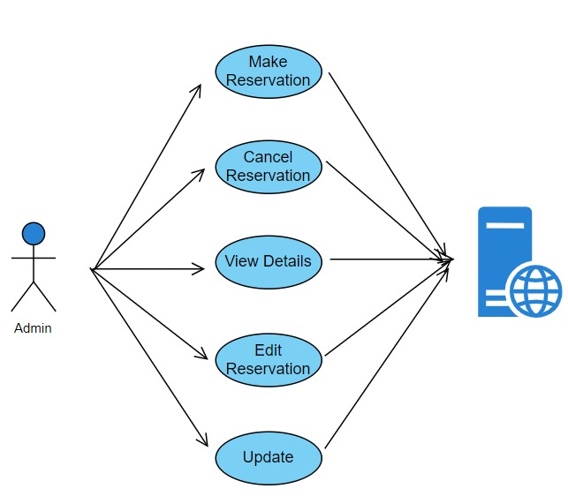

**2.2 Product Diagram**

Entity Relationship of Diagram of Airline Reservation System

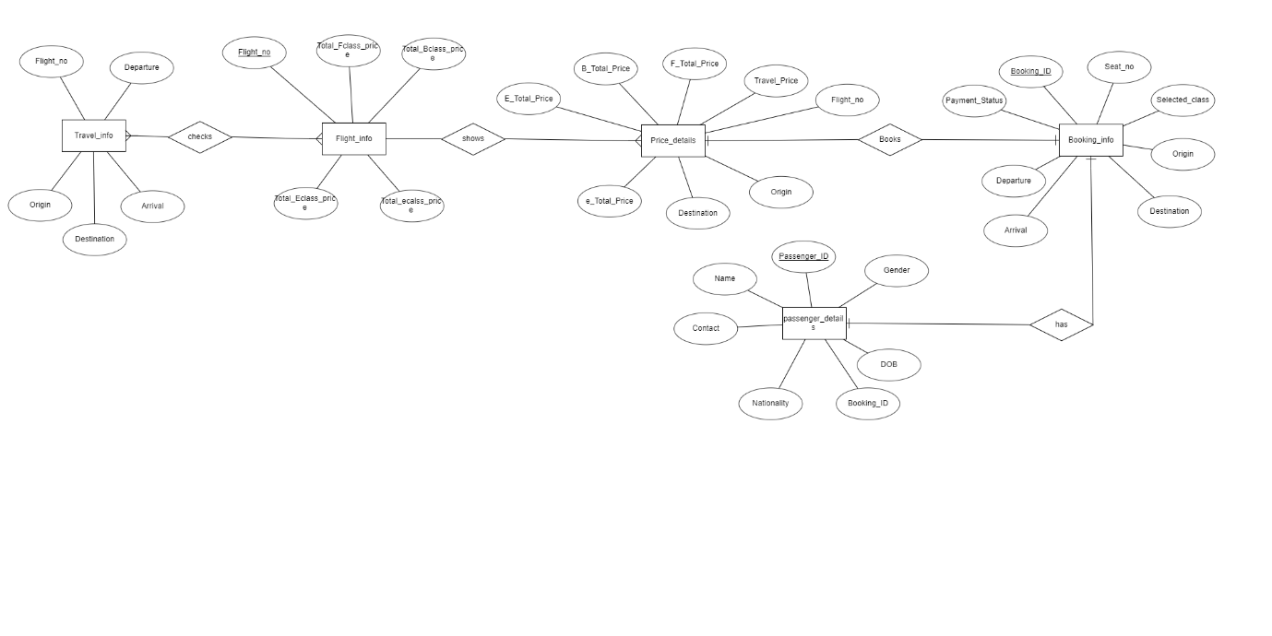

**2.3 User Classes and Characteristics**

* Admin can make changes or modify existing flight details such as departure, arrival, destination available seat, etc.
* Admin can remove the flights that are not active.
* Admin can arrange and modify seating arrangements for each flight.
* Admin can monitor and manage the seat availability.
* Admin can retrieve or view passenger reservation history.
* Admin can view and manage passenger details.
* Admin can edit and update passenger details.
* Admin can create new flight reservations for passengers.
* Admin can cancel reservations and manage refund policies.
* Admin can view and manage ticket details and re-issue the tickets in case of modification.

**2.4 Operating Environment**

The product will be operating in a Windows environment. The Airline Reservation System is a website and shall operate in all famous browsers, a model we are taking Microsoft Internet Explorer, Google Chrome, and Mozilla Firefox. Also, The only requirement to use this online product would be an internet connection. The basic input devices required are a keyboard and mouse, and the output devices are a monitor, printer, etc.

**2.5 Assumptions and Dependencies**

**The assumptions are**

* The coding should be error-free.
* The system should be user-friendly so that it is easy to use for the users.
* The information of all bookings and flight details must be stored in a database that is

accessible by the website.

* The system should have more storage capacity and provide fast access to the database.
* The system should provide a search facility.
* The Airline Reservation System is running 24 hours a day.
* Admins can only login access from the specified computer that has an internet connection.
* Admins must have their correct usernames and passwords to enter into their portals

and do actions.

**The dependencies are**

* The specific hardware and software due to which the product will be run.
* Based on listing requirements and specifications, the project will be developed and

Run.

* The end users (admin) should have a proper understanding of the product.
* The system should have the general report stored.
* The information of all the passengers must be stored in a database that is accessible by the Airline Reservation System.
* Any update regarding the bookings for flights to be recorded to the database and the

data entered should be correct.

**2.6 Requirement**

Software Configuration

* This software package is developed using Java as the front end. Microsoft SQL Server as the back end to store the database.
* Operating System: Windows
* Language: Java Runtime Environment
* Database: My SQL Server

**2.7 Data Requirement**

The inputs consist of the query to the database and the output consists of the solutions for the query. The output also includes the admin receiving the details of the passengers. In this project, the inputs will be the queries as fired by the admins like creating new reservations, selecting seats, and updating the airline reservation system. Now the output will be visible and seats will be modified and updated.

**3 External Interface Requirement**

**3.1 GUI**

The software provides a good graphical interface so the administrator can operate on the system, performing the required tasks such as creating, updating, and viewing the details of the flight, Seat availability, etc.

* It allows the admin to view quick reports of Issued Tickets.
* It allows the admin to make modifications at the backend.
* The admin portal must be customizable by the administrator.
* All the modules provided with the software must fit into this graphical user interface and accomplish the standard-defined.
* The design should be simple and all the different interfaces should follow a standard

Template.

* The admin portal should be able to interact with the user management module and a part of the interface must be dedicated to the login/logout module.

**Login Interface**

* In case the admin is not yet registered, the admin can enter the details and register to create his account.
* Once his account is created admin can ‘Login’ which asks the admin to type his username and password. If the admin entered either his username or password incorrectly then an error message appears.

**Search**

The admin can enter the type of ticket class he is looking for and the price he can afford, then he can search for the seat availability by entering the flight name.

**Categories View**

The categories view shows the categories of tickets and seats available and provides the ability for the admin to add/edit or delete a category from the list.

**Admin’s Control Panel**

This control panel will allow the admin to add/remove passengers, flights, etc, add, edit, or remove a resource. And manage canceling options and refund policies.

**4. System features**

The admins of the system should be provided the surety that their account is secure. This is possible by providing

* Admin User authentication and validation of members using their unique member ID.
* Proper accountability includes not allowing a passenger to see other passengers’s details. Only the administrator will see and manage all passengers' details.

**5. Other Non-functional Requirements**

**5.1 Performance Requirement**

* The proposed system that we are going to develop will be used as the Chief performance system within the airport.
* Therefore, it is expected that the database would perform functionally all the requirements that are specified by the performance of the system should be fast and accurate.
* Airplane reservation System shall handle expected and non-expected errors in ways that prevent loss of information and long downtime periods.
* Thus it should have built-in error testing to identify invalid username/password of the admin.
* The system should be able to handle large amounts of data.
* Thus it should accommodate a high number of passengers without any fault.

**5.2 Safety Requirement**

* The database may be crashed at any certain time due to a virus or operating system failure.
* Therefore, it is required to take the database backup so that the database is not lost.
* A proper UPS/inverter facility should be there in case of power supply failure.

**5.3 Security Requirement**

* The system will use a secured database
* Normal users cannot just read information, and cannot edit or modify anything except the admin who has their login and password.
* Proper user authentication should be provided.
* No one should be able to hack admins' passwords.
* There should be separate accounts for the admin such that no member can access the database and only the admin has the right to update the database.

**5.4 Requirement attributes**

* There may be multiple admins creating the project, but all of them will have the right to

create changes to the system.

* The Quality of the database is maintained in such a way that it can be very user

friendly to all the admins of the database

* The admin will be able to easily book the flights, check availability, and further do the reservation or cancellation.

**5.5 User Requirement**

* The users of the system are admins or persons of the airport who is allotted to do the reservation, checking who act as administrator to maintain the system.
* The members are assumed to have basic knowledge of computers and internet browsing.
* The administrators of the system should have more knowledge of the internals of the system and can rectify the small problems that may arise due to disk crashes, power failures, and other catastrophes to maintain the system.
* The proper user interface, user manual, online help and the guide to install and maintain the system must be sufficient to educate the users on how to use the system without any problems.

The admin provides certain facilities to the users in the form of

* Backup and Recovery
* Data replication i.e. if the data is lost in one branch, it is still stored with the server
* Auto Recovery i.e. frequently auto saving the information
* Maintaining files i.e. File Organization
* The server must be maintained regularly and it has to be updated from time to time

**6. Other Requirements**

**6.1 Data and Category Requirement**

The main category of users is admin. In this category, admins have access that He/she can be able to modify the data, update it or cancel the reservation, and check about the availability of the seats. Also, they can search about the timings of the flights, and availability of the seats and help the passenger to know information and further bookings and modifications can be done by the admin.

**6.2 Glossary**

The following is the list of conventions and acronyms used in this document and the project as well:

* Admin: A login ID representing a user with user administration privileges to the

software

* SQL: Structured Query Language; used to retrieve information from a database
* Class diagram: It is a type of static structure diagram that describes the structure of a

system by showing the system’s cases, their attributes, and the relationships between the classes

* Interface: used to communicate across different mediums

**6.3 Class Diagram**

